Teacher Notes For “How to Reduce the Spread of COVID-19”

In this activity, students analyze information about how the coronavirus is transmitted and how to reduce the risk of coronavirus infection. Several questions engage students in thinking about how their behavior influences the risk of COVID-19 for more vulnerable individuals.

Before your students begin this activity, I recommend that you introduce them to the novel coronavirus and COVID-19 vaccines. For this purpose, I recommend:
- “Coronaviruses – What They Are and How They Can Make You Sick” (https://serendipstudio.org/exchange/bioactivities/coronavirusintro).
- “COVID-19 Vaccines – How do they work?” (https://serendipstudio.org/exchange/bioactivities/coronavirusvaccine)

Learning Goals
In accord with the Next Generation Science Standards:
- This activity helps students to prepare for Performance Expectation HS-LS2-8. “Evaluate the evidence for the role of group behavior on individual… chances to survive and reproduce.”
- Students engage in the Scientific Practices, “Constructing Explanations. Apply scientific ideas, principles and/or evidence to provide an explanation of phenomena and solve design problems, taking into account possible unanticipated effects.”
- This activity helps students to understand the Crosscutting Concept, “Cause and Effect: Mechanism and Prediction. Cause and effect relationships can be suggested and predicted for complex… systems by examining what is known about smaller scale mechanisms within the system.”

Instructional Suggestions and Biology Background
To maximize student participation and learning, I suggest that you have your students work individually or in pairs to complete each group of related questions and then have a class discussion after each group of questions. In each discussion, you can probe student thinking and help them develop a sound understanding of the concepts and information covered before moving on to the next group of related questions.

If your students are learning online, we recommend that they use the Google Doc version of the Student Handout available at https://serendipstudio.org/exchange/bioactivities/coronavirusprev. If you are using the Word version of the Student Handout to make revisions, please check the PDF version to make sure that all figures and formatting are displayed properly in the Word version on your computer.

A key is available upon request to Ingrid Waldron (iwaldron@upenn.edu). The following paragraphs provide additional instructional suggestions and background information – some for inclusion in your class discussions and some to provide you with relevant background that may be useful for your understanding and/or for responding to student questions.

As of September 1, 2021, the estimated number of COVID-19 deaths was 640 thousand in the US and 4.522 million in the world (https://coronavirus.jhu.edu/region/united-states and https://coronavirus.jhu.edu/map.html). You may want to use these sources to check the number of deaths at the time you use this activity with your students.

Obviously, deaths are not the only problem associated with the COVID-19 pandemic. In addition to the acute illness, COVID-19 patients often experience long-term symptoms and new diagnoses after the acute illness. Rates are higher for hospitalized patients, but long-term symptoms are observed even in patients who had mild or asymptomatic COVID-19. For example, ~10% of patients with mild COVID-19 had at least one symptom that negatively affected work or social or home life at eight months (https://www.webmd.com/lung/news/20210412/the-most-common-lingering-symptoms-after-mild-covid). For children and teens aged 6-16, it appears that ~2% experience long-term symptoms such as fatigue, difficulty concentrating, respiratory congestion or abdominal pain (https://wtop.com/coronavirus/2021/07/long-haul-covid-19-symptoms-likely-less-common-in-children-and-adolescents-than-in-adults/).

The recommended 6-minute video, “How Coronavirus Spreads Outdoors vs. Indoors” (https://www.youtube.com/watch?v=n6QwnzbRUyA) provides good explanations for many of the current recommendations about how to minimize the risk of coronavirus infection. One advantage of this video is that it discusses how to reduce your degree of risk, as opposed to trying to be completely safe or completely ignoring the risk of infection. To help your students answer question 1, you may want to show the video, have a brief discussion, have them read question 1, and then watch the video a second time. The commonly used phrase “social distancing” perhaps should be replaced by the phrase “physical distancing” to emphasize that we can still interact with each other by electronic means or at a physical distance; maintaining social connection is important for psychological well-being.

Information about the effectiveness and limitations of vaccines is available in the prerequisite activity, “COVID-19 Vaccines – How do they work?” (https://serendipstudio.org/exchange/bioactivities/coronavirusvaccine). Current estimates indicate that almost 3% of American adults are immunocompromised due to conditions like HIV or treatment with corticosteroids or treatment for cancer or organ transplants (https://thebulletin.org/2008/01/the-growing-number-of-immunocompromised/).

Questions 2 and 3 introduce the concept that the behavior of everyone in a group affects other group members’ risk of becoming infected with the coronavirus; this can be particularly crucial for vulnerable individuals. As mentioned in the introductory paragraph of the Student Handout, our collective behavior also affects the ability of the coronavirus to evolve increasingly harmful features, which can further increase everyone’s risk due to COVID-19.

During 2020 and 2021, scientists have made rapid progress in understanding how the coronavirus spreads and therefore the most effective methods for reducing the spread of the coronavirus and preventing COVID-19. This evidence has shown that infectious aerosols of tiny respiratory particles are primarily responsible for transmitting COVID-19 (evidence summarized in https://www.medscape.com/viewarticle/949555 and https://www.scientificamerican.com/article/mounting-evidence-suggests-coronavirus-is-airborne-but-health-advice-has-not-caught-up1/). Our current understanding of the importance of transmission by aerosols is the basis for the current emphasis on wearing masks and good ventilation to prevent the spread of COVID-19 among people who need to be inside with others for a long time (e.g. in a classroom). Good ventilation should replace the air in a room with outdoor air every 15-20 minutes (https://www.cdc.gov/coronavirus/2019-ncov/community/ventilation.html). Good ventilation can be supplemented and to some extent replaced by specialized air filters that remove the tiny respiratory particles that can contain coronaviruses. In discussing question 2, you may want to mention that school districts should ensure good ventilation and effective air filtration in classrooms, in addition to the actions that individual students should take to reduce the risk of coronavirus infection for vulnerable classmates.

A good source of information about the contribution of children and adolescents to the spread of COVID-19 and effective measures to reduce the risk of spread of COVID-19 in schools is “Science Brief: Transmission of SARS-Cov-2 in K-12 Schools and Early Care and Education Programs – Updated” (https://www.cdc.gov/coronavirus/2019-ncov/science/science-briefs/transmission_k_12_schools.html).

Question 4 addresses the frequent failure of people to remember that respiratory transmission of the coronavirus means that effective masks must cover the nose as well as the mouth and be well fitting all around. Well-fitting masks reduce the risk that the wearer will become infected, as well as reducing the risk that the wearer will transmit infection. Cloth masks are protective, particularly if they have multiple layers. For practical advice, see https://www.cdc.gov/coronavirus/2019-ncov/prevent-getting-sick/about-face-coverings.html, https://health.clevelandclinic.org/how-to-keep-your-glasses-fog-free-while-wearing-a-mask/, https://www.youtube.com/watch?v=EHVyy08L2gM and https://www.racv.com.au/royalauto/living/community/face-mask-wearing-hacks.html .

As discussed in question 5, the CDC and other experts are advising that even vaccinated students and staff should wear masks in schools. This advice is based on evidence that vaccinated people can contribute substantially to the spread of the Delta variant of the coronavirus (https://www.nytimes.com/2021/07/30/health/cdc-vaccinated-delta.html). In discussing question 5, you may want to mention that more than half of new cases of COVID-19 are caused by transmission of coronavirus infections from people who do not have symptoms (https://www.washingtonpost.com/science/2021/01/07/covid-asymptomatic-spread/).

The figure below shows how the risk of transmission is believed to be influenced by multiple factors, including wearing face coverings, time spent in a setting, outdoor vs. indoor location, degree of ventilation, number of people in the setting, and whether they are speaking or shouting and singing. The authors estimated the risks of transmission for situations where “everyone is asymptomatic”.

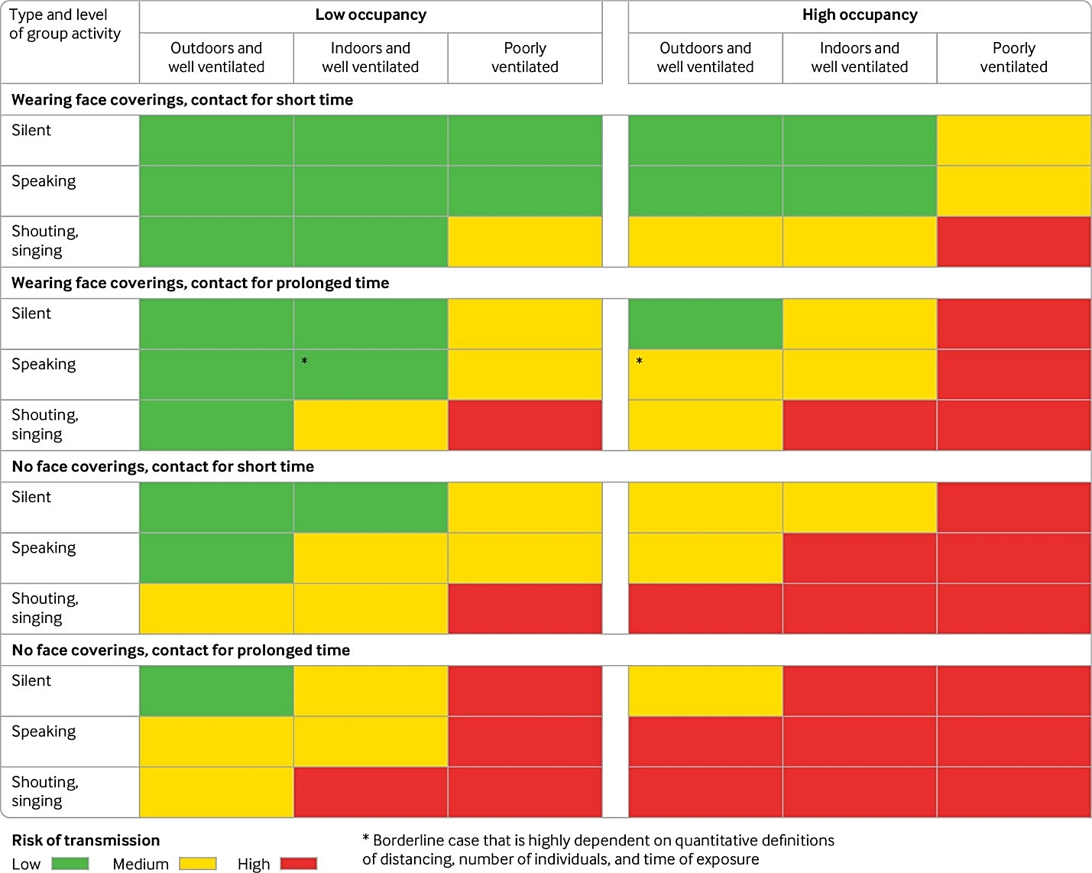
Risk of SARS-CoV-2 transmission from asymptomatic people in different settings and for different occupation times, venting, and crowding levels (ignoring variation in susceptibility and viral shedding rates). Face covering refers to those for the general population and not high grade respirators. The grades are indicative of qualitative relative risk and do not represent a quantitative measure. Other factors not presented in these tables may also need to be taken into account when considering transmission risk, including viral load of an infected person and people’s susceptibility to infection. Coughing or sneezing, even if these are due to irritation or allergies while asymptomatic, would exacerbate risk of exposure across an indoor space, regardless of ventilation (https://www.bmj.com/content/370/bmj.m3223)

No single method of prevention provides foolproof protection, so we need multiple methods of prevention to minimize our risk. This principle is embodied in the CDC “Guidance for COVID-19 Prevention in K-12 Schools” (https://www.cdc.gov/coronavirus/2019-ncov/community/schools-childcare/k-12-guidance.html). The figure below conveys the basic point that no single type of prevention is foolproof, so multiple preventive actions have the best chance to stop the spread of COVID-19. We need a combination of vaccination, public health measures, and individual responsibility to effectively slow down the spread of the coronavirus.

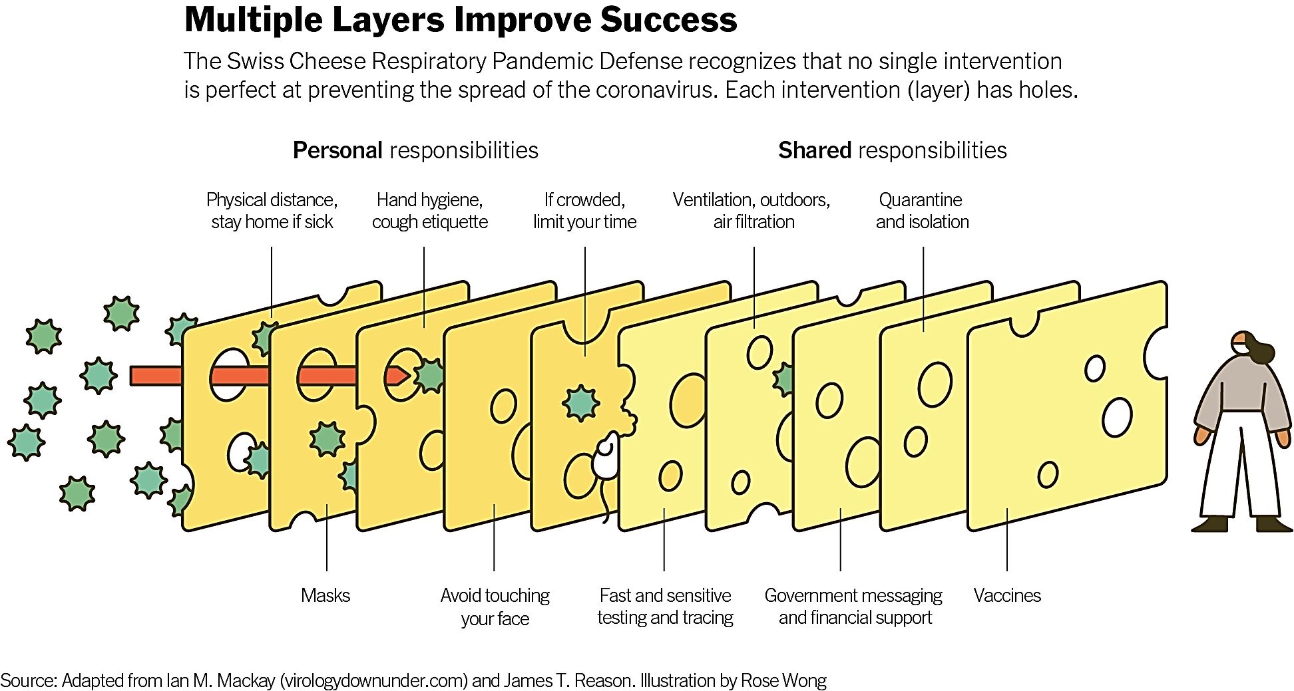
(https://www.nytimes.com/2020/12/05/health/coronavirus-swiss-cheese-infection-mackay.html)

Follow-Up Activities
Where did the new coronavirus come from?
https://serendipstudio.org/exchange/bioactivities/coronavirusOrigin
In this analysis and discussion activity, students explore the main hypotheses about the origins of the new coronavirus that is causing the current pandemic. Students learn how mutations, natural selection, and contact between species can work together to produce a spillover infection. They analyze how a previous coronavirus spillover infection caused an earlier outbreak of human infectious disease. Molecular evidence is presented for students to evaluate the hypothesis that genetic engineering produced the new coronavirus. In addition, students explore possible strategies for preventing new spillover infections.

How Genes Can Cause Disease – Understanding Transcription and Translation
https://serendipstudio.org/exchange/bioactivities#molecbio
After students learn about the processes of transcription and translation, students use their understanding of translation to develop a partial explanation of how the coronavirus replicates inside our cells.

Resources for Teaching about Coronavirus
https://serendipstudio.org/exchange/bioactivities/coronavirus
This compilation provides brief descriptions and links for multiple activities for teaching about coronavirus and COVID-19, as well as several sources of reliable information.

If your students have additional questions about the novel coronavirus and the COVID-19 pandemic, you may want to encourage them to research these questions using the following sources of reliable information.
- the CDC website (https://www.cdc.gov/coronavirus/2019-ncov/index.html),
- Science (https://www.sciencenews.org/editors-picks/2019-novel-coronavirus-outbreak)
- New York Times (https://www.nytimes.com/news-event/coronavirus)

Sources for Student Handout Figures
- Upper figure on page 2, adapted from https://science.sciencemag.org/content/sci/368/6498/1422/F1.large.jpg?width=800&height=600&carousel=1
- Lower figure on page 2, from https://cdn.shopify.com/s/files/1/2185/1497/products/loandsons_bandana_mask_4layersbandanamask_bluesquarepattern_mens_600x.jpg?v=1609192618, https://www.prevea.com/Prevea/media/Wellness-Resources/wearing-a-mask-with-glasses_1200.jpg, and https://images.ctfassets.net/cnu0m8re1exe/3HYTbjlxl6b9Bk9ATJ2P1L/d847dfcc4b90b75847553f4be916b421/shutterstock_1704465010.jpg?fm=jpg&fl=progressive&w=660&h=433&fit=fill

By Dr. Ingrid Waldron, Department of Biology, University of Pennsylvania, 2021. These Teacher Notes and the related Student Handout are available at https://serendipstudio.org/exchange/bioactivities/coronavirusprev.
Quotations are from http://www.nextgenscience.org/sites/default/files/HS%20LS%20topics%20combined%206.13.13.pdf
If your students do not have access to the Internet, you can show them the video or provide printed copies of "The Risks – Know Them – Avoid Them" (https://www.erinbromage.com/post/the-risks-know-them-avoid-them). Systematic reviews of available evidence indicate that people get substantial protection against coronavirus infection if they wear a mask, use goggles or some other form of eye protection, and maintain a distance of at least 1 m from people outside their household (with evidence of greater protection at 2 m) (https://www.thelancet.com/journals/lancet/article/PIIS0140-6736(20)31183-1/fulltext; https://www.thelancet.com/journals/lancet/article/PIIS0140-6736(20)31142-9/fulltext).
An analysis of the evolving evidence and understanding during 2020 is available in an archived activity at https://serendipstudio.org/exchange/bioactivities/coronavirusprevarchive. The Teacher Notes for this archived activity include information on the biology of handwashing.
Contact tracing has shown that “superspreading events” play a significant role in transmitting the coronavirus, with an estimated 10-20% of infected individuals responsible for 80% of all cases of coronavirus infection. As would be expected, most superspreading events have occurred in enclosed spaces. Somewhat surprisingly, many superspreaders had no symptoms of illness. (https://www.washingtonpost.com/health/2020/07/18/coronavirus-superspreading-events-drive-pandemic/). The occurrence of superspreading events means that similar situations may have very different risks of coronavirus infection, depending on whether a superspreader is in the crowd, but there’s no way to tell which crowded party or bar will turn out to be a superspreading event.

